*Florida International University*

*School of Computing and Information Sciences*

Software Engineering Focus

Feature Document

User Story ID #672 Create a mini Leap enabled program

**Name:** Filip Klepsa

**Team Member(s):**

**Project:** AR-VR-VE (Multimodal Interaction with ASL case study)

**Product Owner(s)**: Dr. Francisco Ortega

**Mentor(s)**: Dr. Francisco Ortega

**Instructor**: Dr. Francisco Ortega

**User Story Name: Learn Leap API**

Description:

* As a developer, I want to build a miniature test program that is Leap enabled, so that I can begin exploring what is and is not possible with the API.

Acceptance Criteria

* Successfully set up coding environment.
* Successfully compile a Leap enabled program.

**Use Case**

* Name:
* Actor:
* Preconditions:
* Description <Flow of events>:

**Use Case Diagram <**you can use draw.io**>**

**Sequence Diagram**

**Class Diagram**

**Unit Test**

* Test case ID:
* Description/Summary of Test:
* Pre-condition:
* Expected Results:
* Actual Result:
* Status (Fail/Pass):

**Integration Test**

**Visual User Guide**

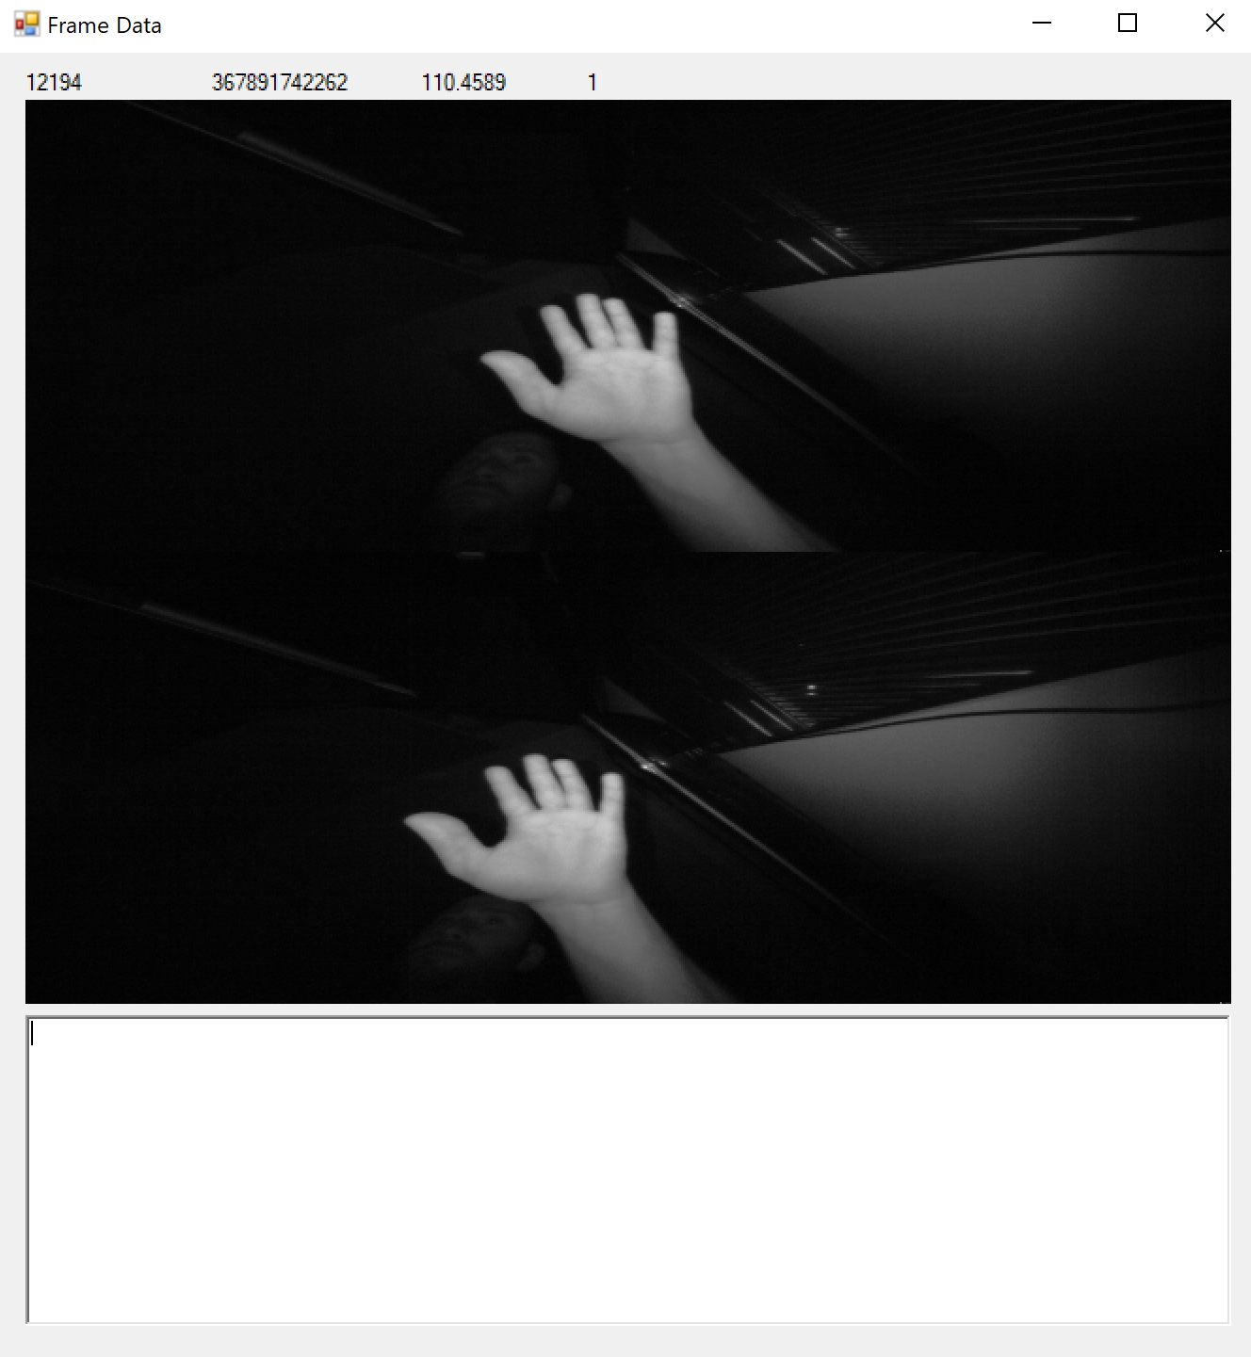  
Mini leap enabled program, provides frame number, FPS, time, and number of hands on the screen.   
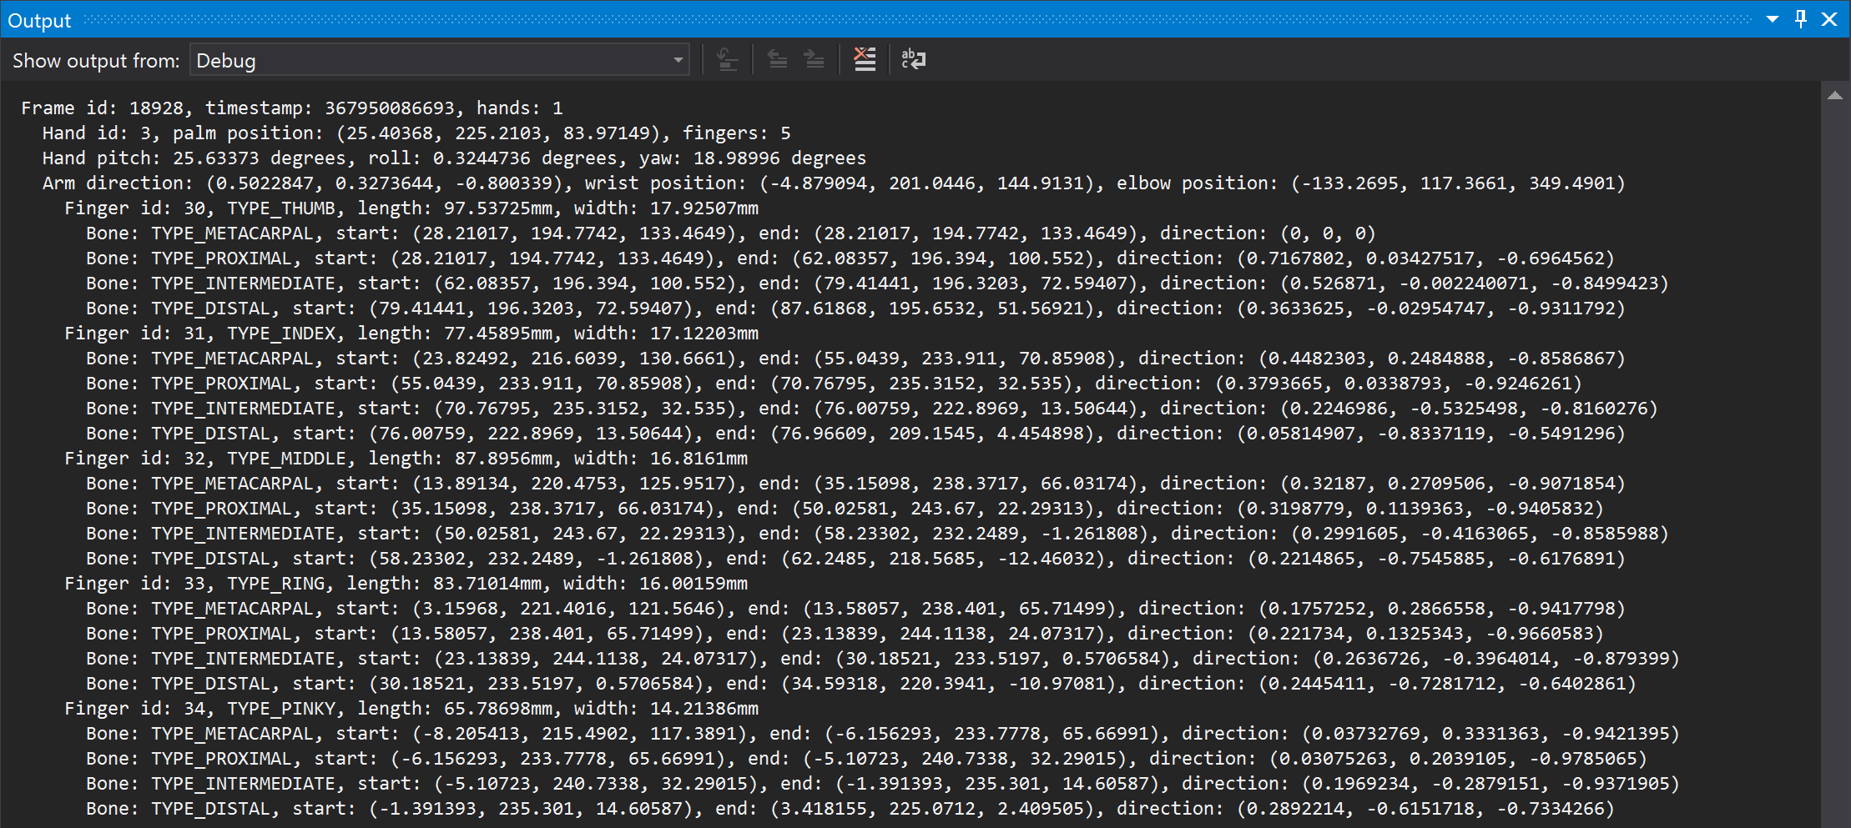  
Frame vector data that is output by the program. This will be needed in order to begin to create the real project.